**Project Presentation:**You will write a presentation that fulfills the requirements of the rubric. Present your findings to the class in a concise, clear way, using graphs and visuals. Tell your report's story in an organized way.

* You're welcome to build your slides in Powerpoint/Keynote/whatever you want. If you do it in a RMarkdown file type (beamer, ioslides, slidy, knit to powerpoint), I'll give you +3 on the project.
* More info on RMarkdown Slides can be found here: <https://rmarkdown.rstudio.com/lesson-11.html>

**Submission:** You will upload a link to a GitHub Repository that contains the final HTML report and presentation, together with the data, the code, and everything else used to generate the reports (images or anything else).

Provide an informative introduction that explains the problem statement you’re answering. Why should I be interested in reading your report?

How much energy do the US states use? How is that energy generated? The total energy generation of different states, then a deep dive into how Texas’s energy is generated.

The Power generation of the US, divided by states.

Graphs-  
US Total Power Generation per year   
  
Total Energy generation for each state ``` should we filter this to showcase one year in particular ???   
  
Total Power Generation Per Year faceted by source – should we mutate other sources into one “other” source and add a note for clarity?

Total Wind Power Generation Per Year

Total Solar Power Generation Per Year

*Add Total Petroleum Power Generation Per Year

Total Power Generation over time for solar, wind and petroleum

Accumulative Total power generation per state since 2001 ```

States with negative power generation ``` what does this actually mean?

Amount of energy generated by different sources generated by year ```

(Texas Graphs)Texas total power generated from 2001-2022

Texas Total Power generated per year ```

Texas Total Power generated per month ```

*Add Texas Wind Power Generated per year  
  
*Add Texas Solar Power Generated per year

*Add Texas Petroleum Power Generated per year

* Total Power Generation over time for solar, wind and petroleum for Texas

- Provide a short explanation of how you’re addressing this problem statement, what data are you using, what methods are you using?

Analyzing the US Energy Information Administration government database for monthly energy generation.

- Discuss your approach and analytic techniques and why it will address this problem.

- Explain how your analysis will help the reader of the analysis

- Presentation is practiced, polished, timed well (doesn’t go significantly under or over time)

- Slides look nice, clean and polished.

- Presentation is organized well, summarizes the project concisely and clearly.

- Graphs and visuals are used to their maximum effect.

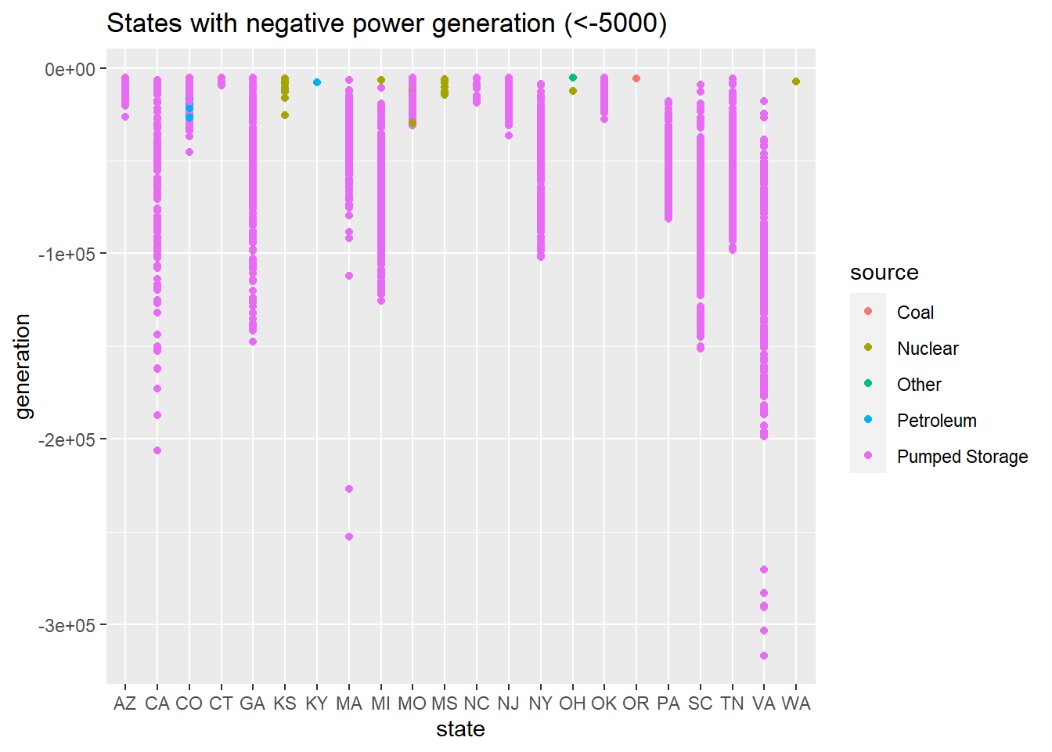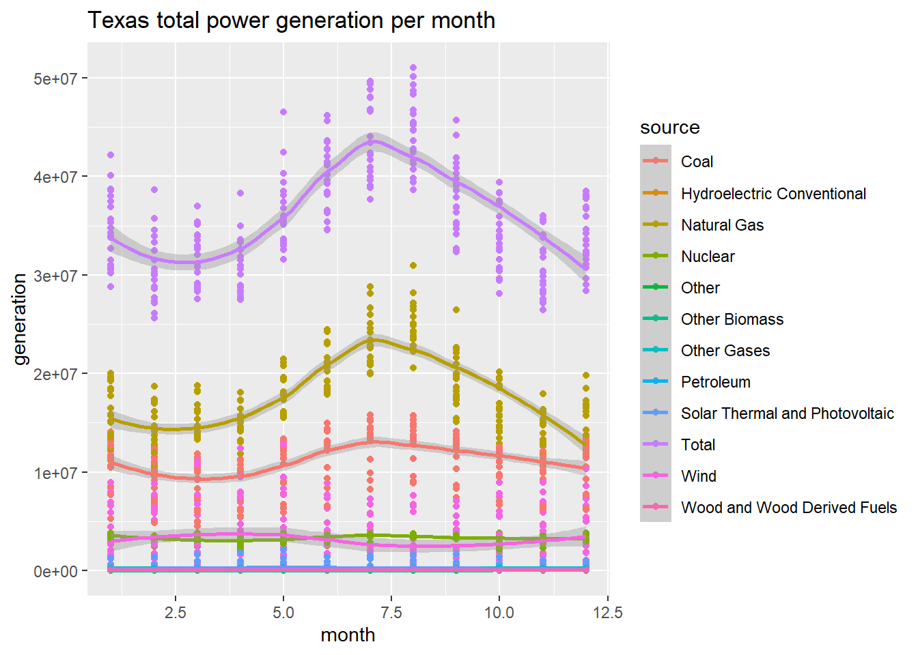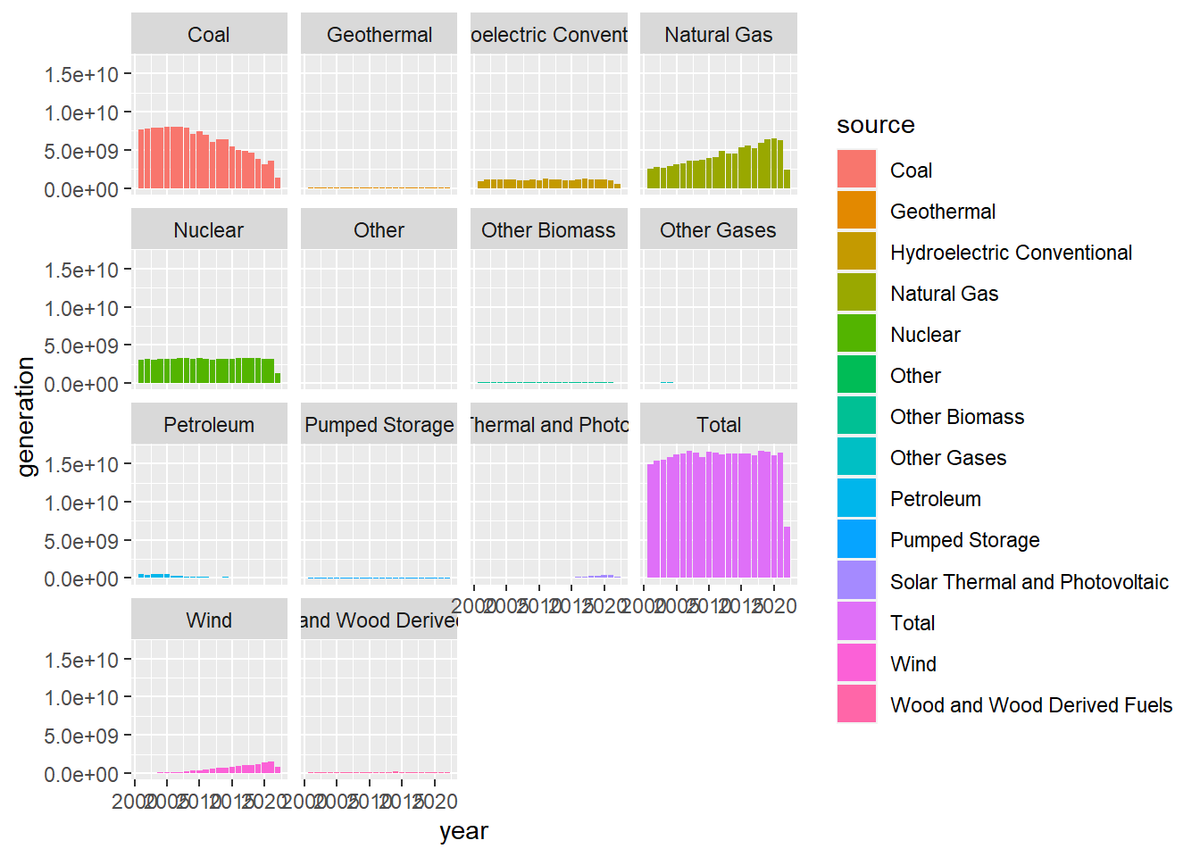  
amount of energy generated by different sources generated by year

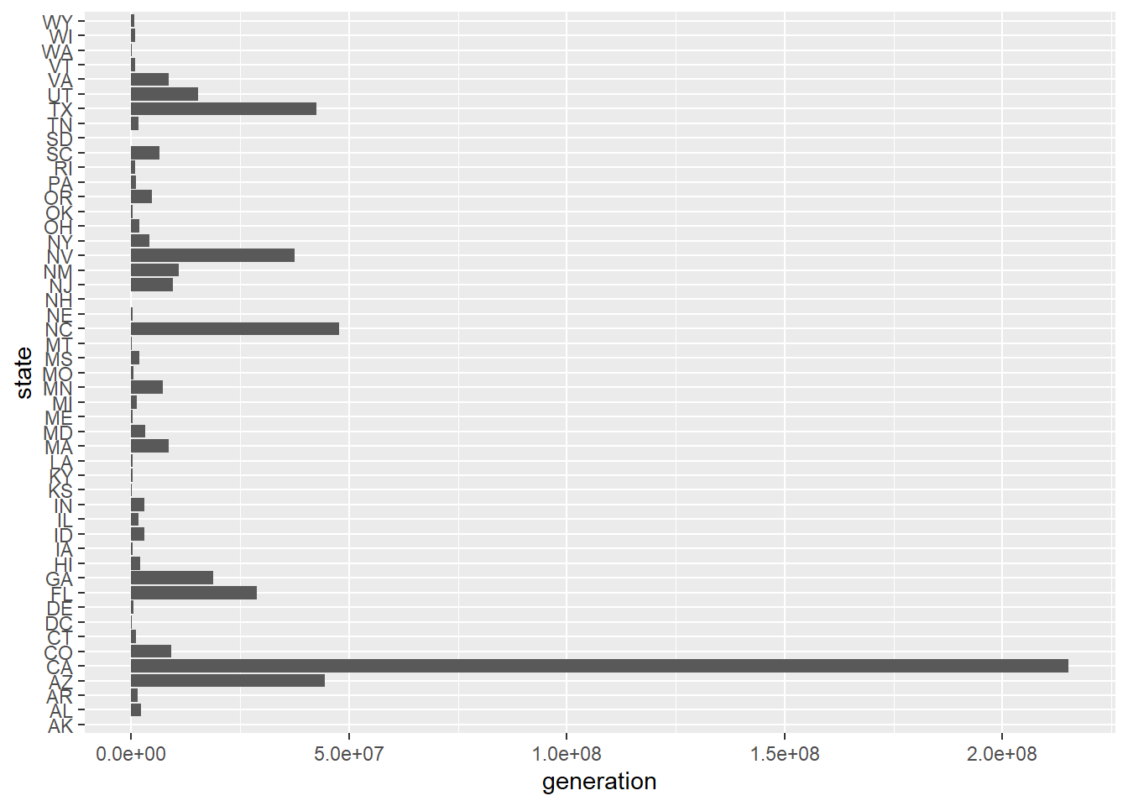  
accumulative total power generation per state since 2000  
